*D:\Dropbox\SC Racers\SC Racers logo\text\logo-text.emfSC Racers*  
Scale F1 team

SC Racers, F1 in Schools Alexander Harfitt

C/O Sha Tin College

No. 3 Lai Wo Lane

Fo Tan, Sha Tin

Hong Kong

11th September 2015

Dear Sir/Madam,

We are **SC Racers**, a **Formula 1 team** made up of six grade 12 students that will be participating in the **F1 in Schools National Competition** at Kellett School, Kowloon Bay, Hong Kong. Our team is representing Sha Tin College (ESF). The National Competition takes place during May/June of 2016 and will be attended by judges from around the world and teams, visitors and possibly even the media from Hong Kong.

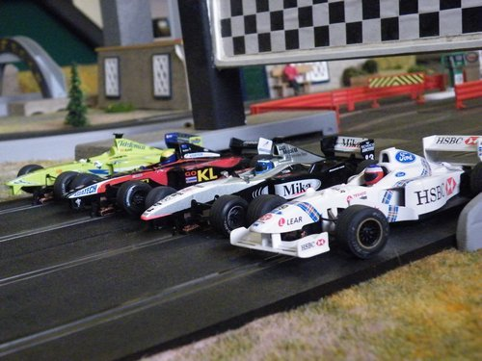We seek sponsorship to help us buy all the resources and materials required to guide us towards our ultimate goal: Success in the World Finals in Austin, Texas.



***Austin 2016 F1 in Schools World Finals***

***Our goal***

**TEXAS 2016**

***Our Team’s undeniable strength and togetherness leads us to believe we can strive for the greatest and achieve it.***

We would be extremely grateful if you would help us, via sponsorship, to achieve our goal. As part of a sponsorship package your company’s logo will appear on our team uniform, which includes a range of specially designed race shirts, or direct branding on the car itself. Your name will be visible and prominent throughout the competition.

If this project is of interest to yourself and your company and you would like to find out more about this initiative then please contact me direct for further details and indication of the level of sponsorship you are willing to offer.

Any monies forwarded should be via a cheque and should be made payable to ‘Sha Tin College’, a receipt of your sponsorship donation will be issued by return.

We would be honoured if you would support us and sponsor our team. Should you have any further queries or questions then please do not hesitate to contact me.

Team Facebook page: <https://www.facebook.com/SCRacers>  
Team email: [sc.racers.f1@gmail.com](mailto:sc.racers.f1@gmail.com)

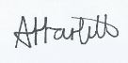Yours faithfully,

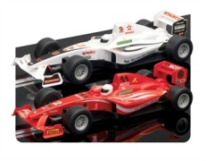

Alexander Harfitt

**SC Racers team manager**